 Discussion 3

A )

Domain: domain of first box is only list and the domain of second box is

any value

Range: this block return only true or false

B)

Domain: domain of this block is number

Range: this block return true or false

The data type of “var” and “foo” are same

|  |  |  |  |
| --- | --- | --- | --- |
| **High order functions** | **Domain** | **Range** | **Note** |
|  | You can put reporter block only in first box  In second box you can put only list | Output of this is only list and the length input and output list is same | The reporter is able is able to take all the data type of input list  The output list finalized the data type of output |
|  | First block take only predicate and second take only list | Output is list with less than or equal to the length of input list | Domain of predicate is contain all data type |
|  | First box take reporter and second take list only | Output is one value of | Data type of input and output list is same |

**High order function practice**

1. Keep items such that from Mylist



2.

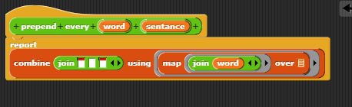

3.

4. the last letter of “our” list is the output

Challenge problems:

Domain : true or false

Range: list of numbers

b.

domain: information is incomplete

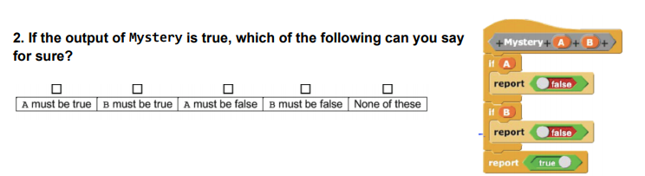range: numbers

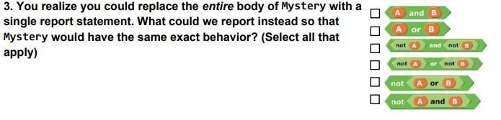

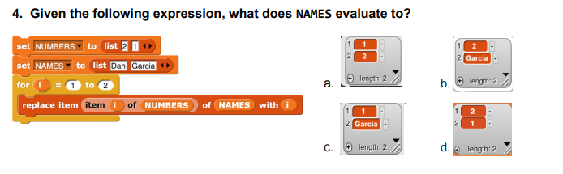

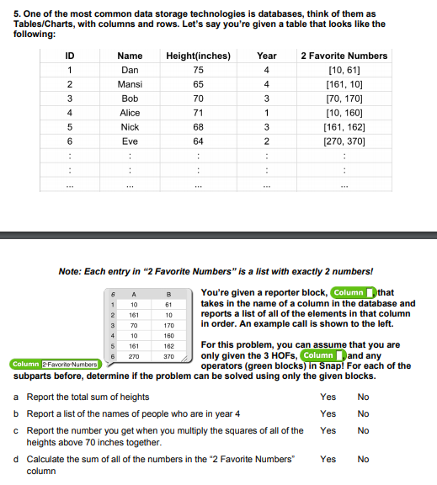

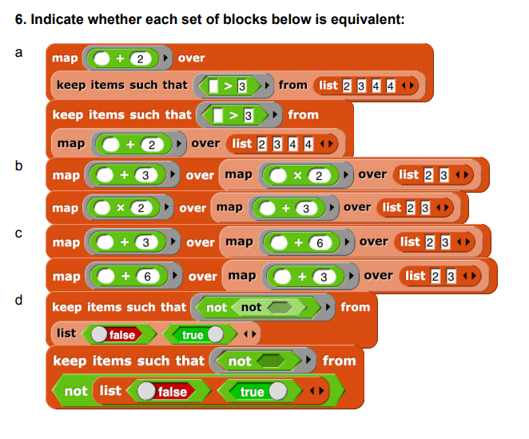 No

NO

Yes

No